
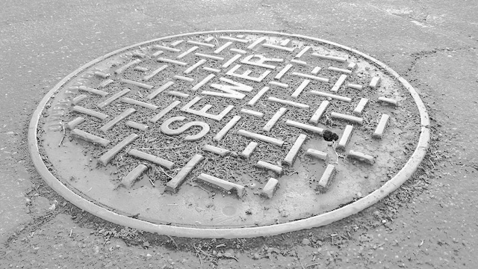



909 Marina Village Parkway #135 § Alameda, CA 94501 § (510) 545-3182 § www.LTmuniconsultants.com

909 Marina Village Parkway #135 § Alameda, CA 94501
(510) 545-3182 § www.LTmuniconsultants.com

909 Marina Village Parkway #135 § Alameda, CA 94501
(510) 545-3182 § www.LTmuniconsultants.com

909 Marina Village Parkway #135 § Alameda, CA 94501
(510) 545-3182 § www.LTmuniconsultants.com

Land’s End Sewer Rate Study
Lake County Sanitation District

Draft Report
March 16, 2026



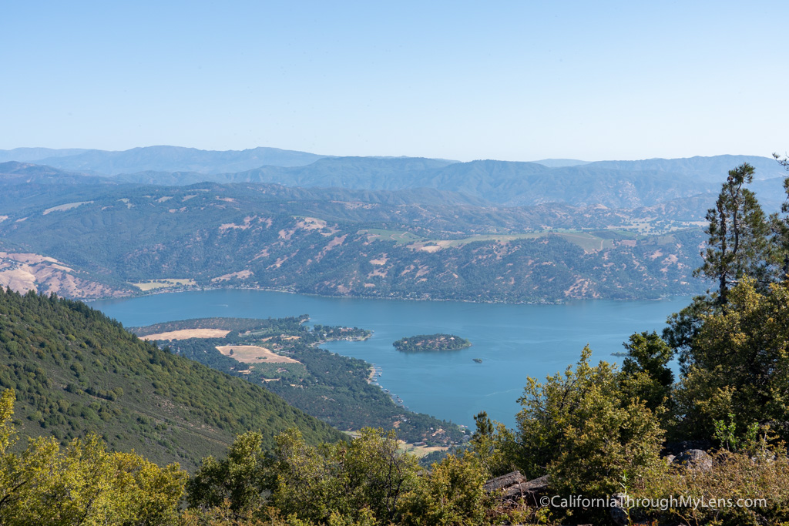

909 Marina Village Parkway #135 § Alameda, CA 94501 § (510) 545-3182 § www.LTmuniconsultants.com

909 Marina Village Parkway #135 § Alameda, CA 94501
(510) 545-3182 § www.LTmuniconsultants.com

909 Marina Village Parkway #135 § Alameda, CA 94501
(510) 545-3182 § www.LTmuniconsultants.com

909 Marina Village Parkway #135 § Alameda, CA 94501
(510) 545-3182 § www.LTmuniconsultants.com

Table of Contents

Section 1: EXECUTIVE SUMMARY 1
1.1 Background 1
1.2 Requirements of Proposition 218 1
1.3 Rate Study Process 2
1.4 Summary of Proposed Rates 3
Section 2: CURRENT RATES AND CUSTOMER BASE 6
2.1 Current Rates 6
2.2 Customer Base and Current Rate Revenues 7
Section 3: REVENUE REQUIREMENT 9
3.1 Reserves 9
3.2 Revenues 10
3.3 Operating Expenses 10
3.4 Capital Improvement Plan 11
3.5 Cash Flow Projection 11
Section 4: COST ALLOCATION AND RATE DESIGN 13
4.1 Methodology 13
4.2 Proposed Cost Allocation 13
4.3 Rate Structure Considerations 14
4.4 Sewer Rate Design 14
4.5 Proposed Sewer Rates 16

List of Tables

Table 1: Current and Proposed Monthly Rates 4
Table 2: Single Family Residential Monthly Bill Impacts 5
Table 3: Current Rates 7
Table 4: Current Rates and Revenues 8
Table 5: Reserve Fund Balances 9
Table 6: Operating Expense Projection 10
Table 7: Capital Improvement Plan 11
Table 8: Cash Flow Projection 12
Table 9: Cost Allocation 14
Table 10: Total Flow and Load Estimates 15
Table 11: Unit Cost Calculation 16
Table 12: FY2026/27 Proposed Rate Impacts 17
Table 13: Proposed Monthly Rates 18

EXECUTIVE SUMMARY

Background
The Land’s End Sanitation District Regional Wastewater Collection area (AD 9-1) is administered by the Lake County Sanitation District (District) and provides wastewater (sewer) service to customers from Land’s End and portions of the Big Valley Rancheria, Soda Bay Road, and South Main Street. Wastewater is treated at the City of Lakeport’s wastewater treatment plant through a formal agreement between the District and the City of Lakeport. The Land’s End system provides service to a population of about 472 through about 234 accounts. Most of the system was constructed over 30 years ago. The Land’s End system includes 40 manholes, over 5 miles of pipe within the gravity collection system, 3 lift stations, and over 2 miles of force main piping conveying the wastewater flows to the connection point with the City of Lakeport’s wastewater collection system.

The Land’s End system’s rate structure consists of a fixed bimonthly charge that varies based on customer class. For ease of understanding, the rates shown in this report are converted to the monthly equivalent rate. Each year, the District has historically implemented inflationary cost increases. The last inflationary rate adjustment became effective February 15, 2025 when rates were increased by 2.80%. Despite these increases, the Land’s End system’s revenues have fallen behind the cost of service and rate adjustments are recommended. Current annual revenues of about $230,000 do not cover fees of about $245,000 paid to the City of Lakeport for treatment. In addition, rates must increase to cover the County’s administrative cost and repair and replacement of the Land’s End collection system.

In addition to meeting the cost of service, the proposed sewer rate adjustments are designed to better reflect estimated flows and pollutant loading of customers. In particular, it is recommended that multifamily residential customers be split into a separate category from single family residential and domestic strength commercial customers. The multifamily sewer rate is proposed to be lower than the single family rate due to lower sewer flows.

Requirements of Proposition 218
The implementation of utility rates in California is governed by the substantive and procedural requirements of Proposition 218 the “Right to Vote on Taxes Act” which is codified as Articles XIIIC and XIIID of the California Constitution. The District must follow the procedural requirements of Proposition 218 for all utility rate increases. These requirements include:
- Noticing Requirement – The District must mail a notice of the proposed rate increases to all affected property owners or ratepayers. The notice must specify the amount of the fee, the basis upon which it was calculated, the reason for the fee, and the date/time/location of a public rate hearing at which the proposed rates will be considered/adopted.
- Public Hearing – The District must hold a public hearing prior to adopting the proposed rate increases. The public hearing must be held not less than 45 days after the required notices are mailed.
- Rate Increases are Subject to Majority Protest – At the public hearing, the proposed rate increases are subject to majority protest. If more than 50% of affected property owners or ratepayers submit written protests against the proposed rate increases, the increases cannot be adopted.

Proposition 218 also established substantive requirements that apply to sewer rates and charges, including:
- Cost of Service - Revenues derived from the fee or charge cannot exceed the funds required to provide the service. In essence, fees cannot exceed the “cost of service”.
- Intended Purpose - Revenues derived from the fee or charge can only be used for the purpose for which the fee was imposed.

- Proportional Cost Recovery - The amount of the fee or charge levied on any customer shall not exceed the proportional cost of service attributable to that customer.

- Availability of Service - No fee or charge may be imposed for a service unless that service is used by, or immediately available to, the owner of the property.

- General Government Services - No fee or charge may be imposed for general governmental services where the service is available to the public at large.

Charges for sewer service are exempt from additional voting requirements of Proposition 218, provided the charges do not exceed the cost of providing service and are adopted pursuant to procedural requirements of Proposition 218.

Rate Study Process
The following is a brief description of the rate study process:

- Revenue Requirements - Revenue requirements are analyzed via a cash flow projection based on the best information currently available such as historical operating results, budgets, audits, and input from District staff. The cash flow serves as a roadmap for funding future operating costs and capital expenditures while maintaining long-term fiscal stability, all of which is calculated in this study to produce rates that will be necessary to recover only the actual cost of the sewer service per parcel under these proposed rates.

- Cost of Service Allocation - The cost of service process builds on the revenue requirement analysis and assigns sewer costs based on functional cost components: flow and wastewater pollutant strength.

- Rate Design - Rate design involves developing a rate structure that fairly recovers costs from customers but does not exceed the proportional cost of the service attributable to each parcel. Final rate recommendations are designed to fund the District’s short- and long-term costs of providing service and fairly allocate costs to all customers.

The rates developed in this report were based on the best available information gathered from District budgets, audits, and input from staff. The proposed rates are based on the reasonable cost of providing service and do not exceed the proportional cost of the service attributable to each parcel.

Summary of Proposed Rates
The proposed rates were developed to fairly recover costs, adhere to California statute, and be affordable to customers. Current and proposed monthly equivalent sewer rates are provided below in Table 1. Rate adjustments are proposed to take effect each July 1 beginning 2026 to 2030. The rate structure is proposed to remain the same except for the addition of a new multifamily rate category.

The District’s current monthly sewer service charge for single family residential customers is $72.93. After the first proposed increase, the single family residential monthly service charge would increase to $126.03 per month. In addition, the capital improvement program (CIP) fee that is billed to all customers is proposed to increase from $4.50 per month to $8.00 on July 1, 2026. The combined single family residential bill impacts are provided in Table 2.

Figure 1 provides a rate survey comparing the current and proposed Land’s End sewer rates with the rates of other local utilities. The average single family customer in Land’s End is estimated to discharge 210 gallons per day of sewer flow. This equates to about 6,300 gallons of monthly flow. This amount of flow was used to calculate bills for the agencies in Figure 1 that charge volumetric or flow-based rates.

Table 1: Current and Proposed Monthly Rates

 |  | Current | Proposed
Description | Billing Unit | FY2025/26 | FY2026/27 | FY2027/28 | FY2028/29 | FY2029/30 | FY2030/31
 |  |  | July 1, 2026 | July 1, 2027 | July 1, 2028 | July 1, 2029 | July 1, 2030
BASE RATE
Single Family Residential | per dwelling | $72.93 | $126.03 | $136.11 | $147.00 | $158.76 | $171.46
Multifamily Residential [1] | per dwelling | $72.93 | $96.02 | $103.70 | $112.00 | $120.96 | $130.63
Low-Strength Commercial [2] | each | $72.93 | $141.30 | $152.60 | $164.81 | $178.00 | $192.24
Medium-Strength Commercial [3] | each | $219.56 | $360.08 | $388.88 | $419.99 | $453.59 | $489.88
High-Strength Commercial [4] | each | $394.34 | $705.36 | $761.78 | $822.73 | $888.54 | $959.63
IN ADDITION TO THE BASE RATES ABOVE
Convalescent/Group Home/Hospital/Detention | per bed | $36.33 | $45.01 | $48.61 | $52.50 | $56.70 | $61.24
Hotel/Motel w/o kitchen | per room | $7.97 | $23.55 | $25.43 | $27.47 | $29.67 | $32.04
Hotel/Motel with kitchen | per room | $12.09 | $45.01 | $48.61 | $52.50 | $56.70 | $61.24
Hotel/Motel (permanently occupied) | per room | $36.33 | $96.02 | $103.70 | $112.00 | $120.96 | $130.63
Laundromat | per machine | $26.09 | $70.65 | $76.30 | $82.41 | $89.00 | $96.12
Theater or Drive-in | per seat/car space | $0.59 | $0.94 | $1.02 | $1.10 | $1.18 | $1.28
Bars and Lounge or Restaurants | per seat over 33 | $1.51 | $1.88 | $2.03 | $2.19 | $2.37 | $2.56
RV & Campgrounds w/o sewer hookup | per space | $4.94 | $7.07 | $7.63 | $8.24 | $8.90 | $9.61
RV & Campgrounds with sewer hookup | per space | $12.09 | $45.01 | $48.61 | $52.50 | $56.70 | $61.24
Schools w/o cafeteria or showers | per student | $1.99 | $3.77 | $4.07 | $4.40 | $4.75 | $5.13
Schools w cafeteria & showers | per student | $4.09 | $3.77 | $4.07 | $4.40 | $4.75 | $5.13
Capital Improvement Program (CIP) Fee | each | $4.50 | $8.00 | $8.00 | $8.00 | $8.00 | $8.00
1 – Apartments, mobile homes, triplexes, quadruplexes, and accessory dwelling units
2 – Professional office, banks, small retail, daycare or day school without cafeteria or showers, fellowship hall or church without a commercial kitchen, coffee shop without a kitchen
3 – Service station or convenience store without grocery or dining, bars without dining, church, fraternity, club house, senior center, theater, hospital, assisted living, group homes, schools with cafeteria and without showers, hotel/motel without dining, detention center, convalescent home, beauty shop, self-service laundromat, car lots, small grocery without deli or butcher shop
4 – Hotels/motels with dining, schools with cafeteria and showers, supermarkets, event center, car wash is proposed to be eliminated from this rate schedule, dry cleaning, gas station with dining or kitchen, short order, takeout restaurant, casino, fitness center, bars and cocktail lounges with dining

Table 2: Single Family Residential Monthly Bill Impacts

 | FY2025/26 | FY2026/27 | FY2027/28 | FY2028/29 | FY2029/30 | FY2030/31
 | Current | July 1, 2026 | July 1, 2027 | July 1, 2028 | July 1, 2029 | July 1, 2030
Base Sewer Rate | $72.93 | $126.03 | $136.11 | $147.00 | $158.76 | $171.46
CIP Fee | $4.50 | $8.00 | $8.00 | $8.00 | $8.00 | $8.00
Total | $77.43 | $134.03 | $144.11 | $155.00 | $166.76 | $179.46
$ Increase |  | $56.60 | $10.08 | $10.89 | $11.76 | $12.70
% Increase |  | 73% | 8% | 8% | 8% | 8%

Figure 1: Monthly Sewer Bill Survey

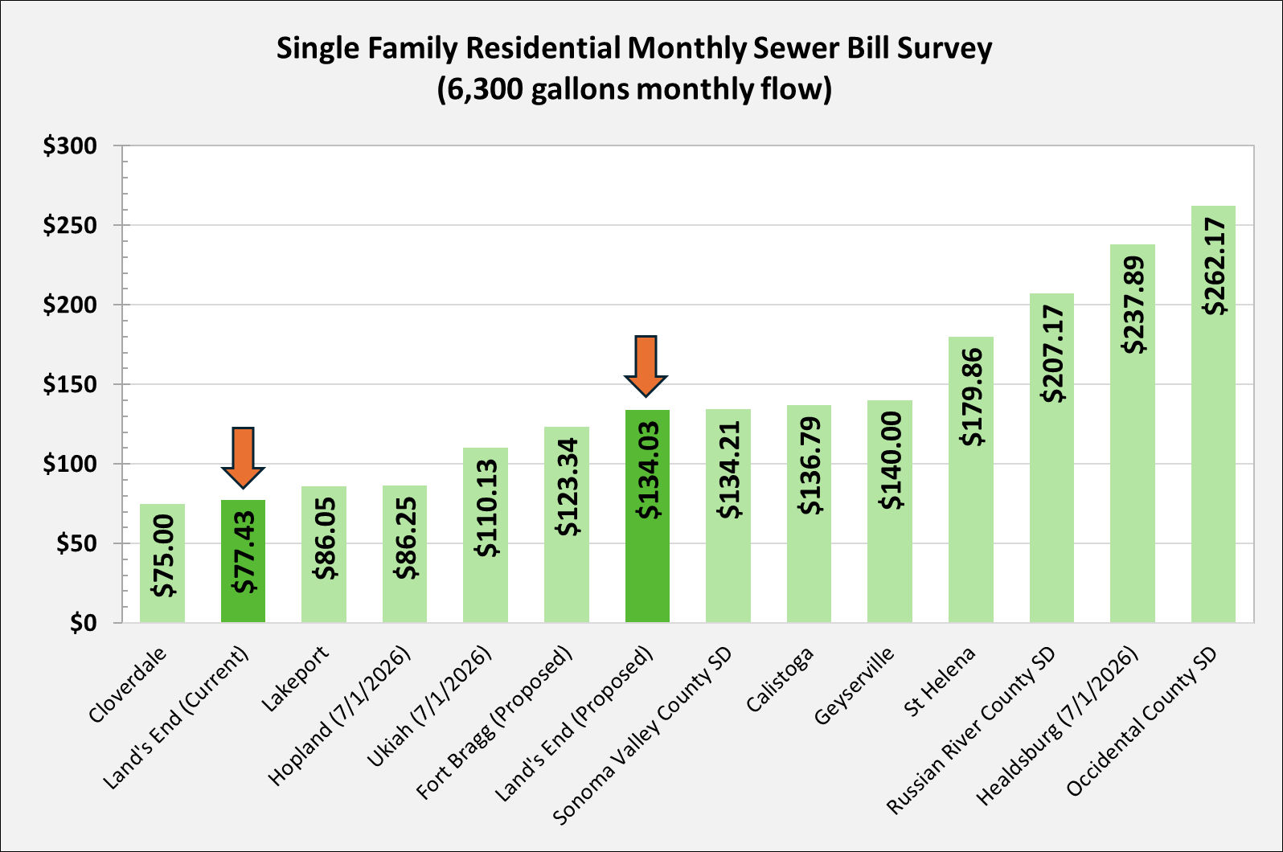

CURRENT RATES AND CUSTOMER BASE

This section provides an overview of the District’s sewer rates, customer base, and current rate revenues. The District bills customers for sewer service on a bimonthly basis such that each billing period covers two months of service. For ease of understanding, the rates in this report are converted to the monthly equivalent. Historically, rates have been increased in February of each year by the annual change in the Consumer Price Index (CPI). The most recent CPI adjustment went into effect February 15, 2025 which raised rates by 2.8%. There was no rate change February 2026 due to the initiation of this rate study.

Current Rates
The schedule of the current monthly sewer rates that went into effect on February 15, 2025 is provided in Table 3. The District charges all customers fixed monthly rates for sewer service and the current rate structure includes two components: (1) Base Rates based on customer type, and (2) Capital Improvement Program (CIP) Fee. Non-residential customers pay base rates delineated by pollutant strength and additional rates based on the type and size of the establishment. For example, restaurants pay a fixed base rate plus additional charges per seat based on the number of seats over 33 per establishment. The District does not bill customers for individualized sewer flows (i.e. volume rates) and instead bills fixed fees based on class average usage characteristics. The CIP Fee is the same for all customer types and is used to fund necessary maintenance and improvement projects within the District.

Table 3: Current Rates

Rate Code | Description | Monthly Fee
BASE RATE
RES | Residential | $72.93
LSC | Low-Strength Commercial | $72.93
MSC | Medium-Strength Commercial | $219.56
HSC | High-Strength Commercial | $394.34
IN ADDITION TO BASE RATES ABOVE
DST | Day care or School w/o Cafeteria or showers; per student | $1.99
MNK | Hotel/Motel w/o kitchen; per room | $7.97
MWK | Hotel/Motel with kitchen; per room | $12.09
UPO | Hotel/Motel or RV/Campground perm. occupied | $36.33
SEAT | Bars/lounge/restaurants - per seat over 33 | $1.51
TSEAT | Theater or Drive-in; per seat or car space | $0.59
RVNS | RV & Campgrounds per space w/o sewer hookup | $4.94
RVWS | RV & Campgrounds per space w/ sewer hookup | $12.09
STU | Schools w/ cafeteria & showers - per student | $4.09
LPM | Laundromat - per machine | $26.09
BED | Convalescent/group home/detention/hospital - per bed | $36.33
ADDITIONAL CHARGES – ALL CUSTOMERS

CIP | Capital Improvement Program (CIP) Fee | $4.50

Customer Base and Current Rate Revenues
Table 4 provides the number of billing units and estimated sewer rate revenues by customer class. Land’s End is a small service area and many rate categories have no customers. In FY2025/26, the District will generate about $238,300 in sewer service charge revenues. Single family residential customers provide the majority of the revenues. The District does not currently have a multifamily rate but billing records indicate that the District provides service to two triplexes and one quadruplex. The total number of multifamily dwelling units is ten.

Table 4: Current Rates and Revenues

FY2025/26
Rate Code | Description | Monthly Fee | Count of Billing Units | Revenue | % of Total
BASE RATE
RES | Single Family Residential | $72.93 | 163 | $142,651 | 60%
NEW | Multifamily Residential | $72.93 | 10 | $8,752 | 4%
LSC | Low-Strength Commercial | $72.93 | 54 | $47,259 | 20%
MSC | Medium-Strength Commercial | $219.56 | 5 | $13,174 | 6%
HSC | High-Strength Commercial | $394.34 | 2 | $9,464 | 4%
 |  |  | 234
IN ADDITION TO BASE RATES ABOVE
DST | Day care or School w/o Cafeteria or showers; per student | $1.99 | - | $0 | 0%
MNK | Hotel/Motel w/o kitchen; per room | $7.97 | - | $0 | 0%
MWK | Hotel/Motel with kitchen; per room | $12.09 | - | $0 | 0%
UPO | Hotel/Motel or RV/Campground perm. occupied | $36.33 | - | $0 | 0%
SEAT | Bars/lounge/restaurants - per seat over 33 | $1.51 | - | $0 | 0%
TSEAT | Theater or Drive-in; per seat or car space | $0.59 | 465 | $3,292 | 1%
RVNS | RV & Campgrounds per space w/o sewer hookup | $4.94 | - | $0 | 0%
RVWS | RV & Campgrounds per space w/ sewer hookup | $12.09 | - | $0 | 0%
STU | Schools w/ cafeteria & showers - per student | $4.09 | - | $0 | 0%
LPM | Laundromat - per machine | $26.09 | - | $0 | 0%
BED | Convalescent/group home/detention/hospital - per bed | $36.33 | - | $0 | 0%
 |  | Subtotal |  | $224,591 | 94%
CIP | Capital Improvement Program | $4.50 | 254 | $13,734 | 6%
Total |  |  |  | $238,325 | 100%

REVENUE REQUIREMENT

Proposition 218 requires that utility rates be based on the reasonable cost of providing service to customers. The cost of service includes annual operating expenses, capital projects, and the accumulation of appropriate reserves. The sewer utility cost of service was developed based on the fiscal year (FY) 2025/26 adopted budget, capital project list developed by staff, and reserve recommendations. Lake County manages Land’s End’s cash flows via two funds: (1) an Operations and Maintenance Fund and (2) Capital Improvement Program Fund. The Operations and Maintenance (O&M) Fund accounts for annual budgeted operating expenses and the Capital Improvement Program (CIP) Fund accounts for infrastructure repairs and replacements.

Reserves
Each of the District’s two funds has its own reserve fund. At the end of FY2024/25, the CIP Reserve had a balance of $3,413 and the O&M Reserve fund balance was $0 as shown in Table 5.

Table 5: Reserve Fund Balances

RESERVE/DESIGNATION CLASSIFICATION |  | Estimated Balance as of 6/30/25
CIP Reserve |  | $3,413
O&M Reserve |  | $0
TOTAL |  | $3,413

One goal of the proposed rate adjustment is to accumulate reasonable reserves to improve the financial health of the utility. It is proposed that the District adopt an O&M Reserve target equal to 50% of annual operating expenses. For FY2025/26, this equates to an operating reserve target of $139,800. This is in line with industry standards. It is also proposed that the capital improvement reserve maintain a balance of $25,000 to fund any urgent repairs.

Adequate fund reserves protect the District when faced with unforeseen financial challenges such as emergency expenses or revenue deficits. It is acceptable if reserves dip below the target on a temporary basis, provided the District takes action to attain the target over the longer run. The District can also choose to use reserves to smooth cash flows and mitigate impacts to ratepayers.

Revenues
For FY2025/26, total revenues for the O&M Fund are estimated at $226,900. Almost all revenue is made up of service charges paid by ratepayers. Additional minor sources of operating revenues include delinquency penalties, interest earnings, and auditing and accounting fees. The only revenue for the CIP Fund is the CIP fee which currently generates about $13,700 annually. No new connections are projected for the five-year rate study period. The first rate adjustment proposed in this report will go into effect for the billing period beginning July 1, 2026. Each subsequent rate adjustment is proposed to go into effect July 1 of each year.

Operating Expenses
In FY2025/26, sewer operating expenses total approximately $279,600. Major line-items include treatment, staffing, utilities, and admin & overhead. Most of the District’s operating costs are made up of treatment fees paid to the City of Lakeport. This year, treatment expenses are projected to total about $246,000 and permitting costs are about $4,400. Current total rate revenues of about $238,300 do not cover this cost.

Over the next five years, most cost categories are projected to increase by 3% annually due to inflation, see Table 6. In addition, treatment and permitting costs are expected to increase by $20,000 in FY2026/27 for the Sanitary Sewer Management Plan (SSMP). Maintenance costs are also expected to increase by $50,000 in FY2026/27 for the lining of lift stations and replacing pumps. This higher maintenance cost is projected to continue throughout the rate study period.

Table 6: Operating Expense Projection

 | Budget | Escalation Factor | Projected
 | FY2025/26 | Escalation Factor | FY2026/27 | FY2027/28 | FY2028/29 | FY2029/30 | FY2030/31
Admin & Overhead | $5,200 | 3% | $15,400 | $5,900 | $6,100 | $6,300 | $6,500
Treatment & Permitting [1] | $250,800 | 3% | $278,300 | $286,600 | $295,200 | $304,100 | $313,200
Staffing | $13,100 | 3% | $36,800 | $37,900 | $39,000 | $40,200 | $41,400
Maintenance [2] | $1,000 | 3% | $51,000 | $52,500 | $54,100 | $55,700 | $57,400
Utilities | $9,500 | 3% | $9,800 | $10,100 | $10,400 | $10,700 | $11,000
Total Operating Expenses | $279,600 |  | $391,300 | $393,000 | $404,800 | $417,000 | $429,500
1 – There is a $20,000 increase in FY2026/27 for the Sanitary Sewer Management Plan.
2 – Maintenance of lining lift stations and replacing pumps is estimated to be $50,000 in FY2026/27 and increase 3% each subsequent year.

Capital Improvement Plan
The District’s 5-year capital improvement plan is provided below in Table 7. The plan was developed by County staff. The County anticipates spending about $87,500 total on capital improvements between FY2026/27 and FY2030/31. The County intends to purchase a new sewer cleaning Pumper Truck in FY2029/30. The cost of the truck will be shared by multiple service areas. Land’s End’s allocated share of the truck is $15,000.

Table 7: Capital Improvement Plan

 | Budget | Projected |  |  |  |  | 5-Year
Project | FY2025/26 | FY2026/27 | FY2027/28 | FY2028/29 | FY2029/30 | FY2030/31 | Total
Rate Study | $20,000 | $0 | $0 | $0 | $0 | $25,000 | $25,000
SCADA Upgrades | $0 | $5,000 | $0 | $0 | $0 | $0 | $5,000
Air Release Valves | $0 | $5,000 | $0 | $0 | $0 | $0 | $5,000
Software | $0 | $7,500 | $7,500 | $7,500 | $7,500 | $7,500 | $37,500
Pumper Truck | $0 | $0 | $0 | $0 | $15,000 | $0 | $15,000
Total | $20,000 | $17,500 | $7,500 | $7,500 | $22,500 | $32,500 | $87,500

Cash Flow Projection
Based on the FY2025/26 adopted budget, the Land’s End O&M Fund currently has a fund balance of $0 and is expected to operate at a deficit this year. This will cause a negative fund balance of $52,700 for the O&M Fund by June 30, 2026. Similarly, the CIP Fund is projected to end the current fiscal year with a negative balance of $2,900. Negative balances represent cost overruns that will be paid via other Lake County funds in the short-term and must be repaid by Land’s End over the five-year rate study period. Rate increases are proposed such that the following objectives are met, in order of importance:

- Fund operating costs
- Fund capital costs
- Repay negative fund balances
- Accumulate reserves by end of the five-year rate study period equal to 50 percent of annual operating expenses plus the annual cost of miscellaneous repairs ($25,000)

The cash flow for the Land’s End Sanitary District system is provided in Table 8. The first operating rate increase will go into effect July 1, 2026 with subsequent rate increases July 1 of each year thereafter. To cover the costs described above, the first O&M rate increase is proposed to generate 75% more rate revenues than current rates. This rate increase is needed to meet operating costs and reverse the deficit. Further O&M rate increases of 8% each year from FY2027/28 to FY2030/31 are proposed to keep up with inflationary cost increases, repay the negative fund balance, and accumulate reserves. The CIP fee is proposed to increase from $4.50 to $8.00 per month to fund capital project costs and accumulate reserves.
Table 8: Cash Flow Projection

 | BUDGET | PROJECTED
 | FY2025/26 | FY2026/27 | FY2027/28 | FY2028/29 | FY2029/30 | FY2030/31
Effective Date |  | July 1, 2026 | July 1, 2027 | July 1, 2028 | July 1, 2029 | July 1, 2030
Rate Revenue Increase |  | 75% | 8% | 8% | 8% | 8%
Beginning Fund Balance | $0 | ($52,700) | ($48,600) | ($14,800) | $41,200 | $121,700
Revenues
Service Charges | $224,600 | $393,100 | $424,500 | $458,500 | $495,200 | $534,800
Delinquencies | $1,300 | $1,300 | $1,300 | $1,300 | $1,300 | $1,300
Interest | $900 | $900 | $900 | $900 | $900 | $900
Auditing & Accounting Fees | $100 | $100 | $100 | $100 | $100 | $100
Total Revenues | $226,900 | $395,400 | $426,800 | $460,800 | $497,500 | $537,100
Operating Expenses
Admin & Overhead | $5,200 | $15,400 | $5,900 | $6,100 | $6,300 | $6,500
Treatment & Permitting | $250,800 | $278,300 | $286,600 | $295,200 | $304,100 | $313,200
Staffing | $13,100 | $36,800 | $37,900 | $39,000 | $40,200 | $41,400
Maintenance | $1,000 | $51,000 | $52,500 | $54,100 | $55,700 | $57,400
Utilities | $9,500 | $9,800 | $10,100 | $10,400 | $10,700 | $11,000
Total Operating Expenses | $279,600 | $391,300 | $393,000 | $404,800 | $417,000 | $429,500
Net Operating Revenues | ($52,700) | $4,100 | $33,800 | $56,000 | $80,500 | $107,600
Ending Fund Balance | ($52,700) | ($48,600) | ($14,800) | $41,200 | $121,700 | $229,300
Operating Fund Target | $139,800 | $195,650 | $196,500 | $202,400 | $208,500 | $214,750
Target Met? (6 months O&M) | No | No | No | No | No | Yes
CAPITAL IMPROVEMENT PROJECT FUND
Beginning Capital Fund Balance | $3,400 | ($2,900) | $4,000 | $20,900 | $37,800 | $39,700
Capital Revenues ($ rate) | $4.50 | $8.00 | $8.00 | $8.00 | $8.00 | $8.00
Capital Improvement Charges | $13,700 | $24,400 | $24,400 | $24,400 | $24,400 | $24,400
Capital Projects (Rate Funded)
Rate Study | $20,000 | $0 | $0 | $0 | $0 | $25,000
SCADA | $0 | $5,000 | $0 | $0 | $0 | $0
Air Release Valves | $0 | $5,000 | $0 | $0 | $0 | $0
Software | $0 | $7,500 | $7,500 | $7,500 | $7,500 | $7,500
Pumper Truck | $0 | $0 | $0 | $0 | $15,000 | $0
Total Capital Expenses | $20,000 | $17,500 | $7,500 | $7,500 | $22,500 | $32,500
Net Capital Revenues | ($6,300) | $6,900 | $16,900 | $16,900 | $1,900 | ($8,100)
Ending Fund Balance | ($2,900) | $4,000 | $20,900 | $37,800 | $39,700 | $31,600
Fund Target | $25,000 | $25,000 | $25,000 | $25,000 | $25,000 | $25,000
Target Met? ($25,000) | No | No | No | Yes | Yes | Yes

COST ALLOCATION AND RATE DESIGN

The revenue requirements detailed in the previous section determine the amount of revenue to be recovered from sewer rates. The cost of service allocation determines how revenues will be recovered from customers based on their estimated impact on the sewer system. Proposition 218 requires that agencies providing “property-related services” (including sewer service) set rates and charges that are based on the cost of providing those services.

Methodology
The determination of the sewer flows, sewer loadings, and the revenue requirements of the sewer utility provide the basis for performing the cost of service allocation. The concept of proportionate allocation to each customer class indicates that allocations should take into consideration the quantity of effluent a customer contributes in addition to the strength of sewer effluent.

The key factors used to assign sewer utility costs are estimated effluent (flow) going to the wastewater treatment plant and effluent strengths, measured in biochemical oxygen demand (BOD) and total suspended solids (TSS). Higher levels of BOD or TSS typically equate to increased treatment costs. The total revenue requirement shown in the sewer cash flow projection is the net cost of providing service and is allocated to the flow, BOD, and TSS parameters. These allocations are then used as the basis to develop unit rates for the sewer parameters and to assign costs to each customer class in proportion to the sewer services rendered.

Using the FY2025/26 budget as the base year, sewer expenses are allocated to the following categories (a) Flow, (b) Biochemical Oxygen Demand (BOD), and (c) Total Suspended Solids (TSS).

- Flow Costs: Volume- or flow-related costs that vary with the total quantity of wastewater collected. The County determined that the flow of a typical single family residential customer is 210 gallons per day. The flows of other customer classes were estimated based on industry typical sewer generation rates.

- Strength Costs: Strength-related costs are those expenditures associated with the additional handling and treatment of high strength sewer. Sewer strength is typically measured in BOD and TSS. Increased levels of BOD or TSS typically equate to increased treatment costs.

Proposed Cost Allocation
The budgeted expenses for FY2025/26 were allocated to flow, BOD, and TSS based on the type of expense and how the District incurs cost. For instance, treatment expenses are allocated 50% to flow, 25% to BOD, and 25% to TSS because these expenses are more heavily impacted by pollutants. All other expenses are allocated to flow as all other costs are related to operating the collection system. In total, 55.2% of expenses are allocated to flow, 22.4% to BOD, and 22.4% to TSS, see Table 9.
Table 9: Cost Allocation

Expenses | FY2025/26 | Flow | BOD | TSS
Admin & Overhead | $5,200 | 100.0% | 0.0% | 0.0%
Treatment | $250,800 | 50.0% | 25.0% | 25.0%
Staffing | $13,100 | 100.0% | 0.0% | 0.0%
Maintenance | $1,000 | 100.0% | 0.0% | 0.0%
Utilities | $9,500 | 100.0% | 0.0% | 0.0%
Subtotal Operating Costs | $279,600 | $154,200 | $62,700 | $62,700
Total Allocation % |  | 55.2% | 22.4% | 22.4%

Rate Structure Considerations
As part of the rate study process, the District reviewed its current rate structure and potential alternative rate structures. Sewer rates in California are typically charged as either a fixed charge per billing unit, a volume rate per unit of wastewater flow, or as a combination of both fixed and volume charges. Ultimately, this study does not recommend any major changes to the current sewer rate structure. Fixed sewer charges provide revenue stability, are easy for customers to understand, and are straightforward to bill. Moreover, the District provides only sewer service to Land’s End and does not have access to metered water usage data that could otherwise be used to estimate flows.

The amount charged to individual customers is proposed to change each year, but the categories of charges and customer classes are proposed to remain the same apart from two changes. The first proposed change is the addition of a multifamily rate. A new multifamily rate is proposed because of the relatively lower flows of the typical multifamily residential customer on average in comparison to the typical single family residential customer. It is also proposed that day care and school customers be combined into one rate category since they have similar flow and loading characteristics. Rates are apportioned based on the updated flow and pollutant loadings for each class as described below.

Sewer Rate Design
The District does not directly meter the wastewater flow of individual utility accounts. However, influent data from the treatment plant was analyzed and flows of each customer class were approximated using a combination of available treatment plant and water use data and industry standard estimates. Total system flows and pollutant loads are estimated in Table 10. Flows are estimated in gallons per day (gpd). The average domestic strength single family residential or commercial sewer flow is estimated as 210 gpd and the estimated multifamily residential sewer flow per dwelling unit is 160 gpd. Pollutant loads consist of biochemical oxygen demand (BOD) and total suspended solids (TSS). The loading for residential customers is assumed to be 110 milligrams per liter (mg/l) for BOD and 350 mg/l for TSS. Loading estimates for non-residential customers are based on general industry guidelines. The estimates shown below result in a total calculated flow of about 20.97 million gallons per year or about 58,000 gpd which is close to actual dry weather flows of about 61,000 gpd. To be fiscally conservative, it is assumed that the District will experience little to no growth over the next five years. Therefore, the flows and loads shown in Table 10 are assumed to remain constant through FY2030/31.

Table 10: Total Flow and Load Estimates

Customer Class | Units | Billing Unit Count | Estimated Flow (gpd) | BOD (mg/L) | TSS (mg/L) | Flow (gal per year) | BOD (lbs/yr) | TSS (lbs/yr)
Single Family Residential | Dwelling Unit | 163 | 210 | 110 | 350 | 12,493,950 | 11,469 | 36,493
Multifamily Residential | Dwelling Unit | 10 | 160 | 110 | 350 | 584,000 | 536 | 1,706
Low-Strength Commercial | Each | 54 | 300 | 75 | 150 | 5,913,000 | 3,701 | 7,402
Medium-Strength Commercial | Each | 5 | 600 | 110 | 350 | 1,095,00 | 1,005 | 3,198
High-Strength Commercial | Each | 2 | 750 | 300 | 600 | 547,500 | 1,371 | 2,741
Convalescent/Group Home/Hospital | Per bed | 0 | 75 | 110 | 350 | 0 | 0 | 0
Hotel/Motel w/o kitchen | Per room | 0 | 50 | 75 | 150 | 0 | 0 | 0
Hotel/Motel with kitchen | Per room | 0 | 75 | 110 | 350 | 0 | 0 | 0
Hotel/Motel (permanently occupied) | Per room | 0 | 160 | 110 | 350 | 0 | 0 | 0
Laundromat | Per machine | 0 | 150 | 75 | 150 | 0 | 0 | 0
Theater or Drive-in | Per seat or car space | 465 | 2 | 75 | 150 | 339,450 | 212 | 425
Bars and Lounge or Restaurants | Per seat over 33 | 0 | 2 | 300 | 600 | 0 | 0 | 0
RV & Campgrounds w/o sewer hookups | Per space | 0 | 15 | 75 | 150 | 0 | 0 | 0
RV & Campgrounds with sewer hookups | Per space | 0 | 75 | 110 | 350 | 0 | 0 | 0
Schools [1] | Per student | 0 | 8 | 75 | 150 | 0 | 0 | 0
 |  |  |  |  |  | 20,972,900 | 18,295 | 51,966
1 - Schools and day cares are proposed to be combined into a single category

Table 11 provides the unit cost calculation for the flow, BOD, and TSS cost categories. The total proposed rate revenue requirement for FY2026/27 is divided between the categories based on the percentages developed in Table 9. The revenue requirement for each category is then divided by the total annual billing units for flow, BOD, and TSS from Table 10 to calculate unit charges.

Table 11: Unit Cost Calculation

Cost Allocation | Total | Flow | BOD | TSS
Cost Allocation % |  | 55.2% | 22.4% | 22.4%
FY2026/27 O&M Revenue Requirement | $393,100 | $216,800 | $88,200 | $88,200
Billing Units |  | 20,972,900 | 18,295 | 51,966
 |  | gal/year | lbs/year | lbs/year
Rate |  | $10.34 | $4.82 | $1.70
 |  | $/1000 gal | $/lb | $/lb

Proposed Sewer Rates
As a first step in calculating the sewer O&M rates, the unit charges detailed in Table 11 above were multiplied by the flow and loading assumptions in Table 10 for each customer class to calculate the total monthly rate for FY2026/27. Table 12 shows the percentage change for each customer class and the estimated annual rate revenues not including the CIP fee revenues.

The rates for future years were calculated as the previous year’s rate increased by the annual percent change to correspond to the increase in revenue requirement shown in Table 8 (8% for FY2027/28, for example). The five-year proposed rate plan is provided in Table 13.

Table 12: FY2026/27 Proposed Rate Impacts

Customer Class | Units | Current Monthly Rate | Proposed Monthly Rate | Rate Change | Projected FY2026/27 Revenue | % of Revenue
Single Family Residential | Dwelling Unit | $72.93 | $126.03 | 73% | $246,505 | 62.7%
Multifamily Residential | Dwelling Unit | $72.93 | $96.02 | 32% | $11,522 | 2.9%
Low-Strength Commercial | Each | $72.93 | $141.30 | 94% | $91,562 | 23.3%
Medium-Strength Commercial | Each | $219.56 | $360.08 | 64% | $21,605 | 5.5%
High-Strength Commercial | Each | $394.34 | $705.36 | 79% | $16,929 | 4.3%
Convalescent/Group Home/Hospital/Detention | per bed | $36.33 | $45.01 | 24% | $0 | 0.0%
Hotel/Motel w/o kitchen | per room | $7.97 | $23.55 | 195% | $0 | 0.0%
Hotel/Motel with kitchen | per room | $12.09 | $45.01 | 272% | $0 | 0.0%
Hotel/Motel (permanently occupied) | per room | $36.33 | $96.02 | 164% | $0 | 0.0%
Laundromat | per machine | $26.09 | $70.65 | 171% | $0 | 0.0%
Theater or Drive-in | per seat or car space | $0.59 | $0.94 | 59% | $5,245 | 1.3%
Bars and Lounge or Restaurants | per seat over 33 | $1.51 | $1.88 | 25% | $0 | 0.0%
RV & Campgrounds w/o sewer hookup | per space | $4.94 | $7.07 | 43% | $0 | 0.0%
RV & Campgrounds with sewer hookup | per space | $12.09 | $45.01 | 272% | $0 | 0.0%
Schools w/o cafeteria or showers | per student | $1.99 | $3.77 | 89% | $0 | 0.0%
Schools w cafeteria & showers | per student | $4.09 | $3.77 | -8% | $0 | 0.0%
 |  |  |  |  | $393,368

Table 13: Proposed Monthly Rates

Rate Code |  |  | Current | Proposed
Rate Code | Description | Billing Unit | FY2025/26 | FY2026/27 | FY2027/28 | FY2028/29 | FY2029/30 | FY2030/31
 |  |  |  | July 1, 2026 | July 1, 2027 | July 1, 2028 | July 1, 2029 | July 1, 2030
 | BASE RATE
RES | Single Family Residential | per dwelling | $72.93 | $126.03 | $136.11 | $147.00 | $158.76 | $171.46
NEW | Multifamily Residential | per dwelling | $72.93 | $96.02 | $103.70 | $112.00 | $120.96 | $130.63
LSC | Low-Strength Commercial | each | $72.93 | $141.30 | $152.60 | $164.81 | $178.00 | $192.24
MSC | Medium-Strength Commercial | each | $219.56 | $360.08 | $388.88 | $419.99 | $453.59 | $489.88
HSC | High-Strength Commercial | each | $394.34 | $705.36 | $761.78 | $822.73 | $888.54 | $959.63
 | IN ADDITION TO THE BASE RATES ABOVE
BED | Convalescent/Group Home/Hospital/Detention | per bed | $36.33 | $45.01 | $48.61 | $52.50 | $56.70 | $61.24
MNK | Hotel/Motel w/o kitchen | per room | $7.97 | $23.55 | $25.43 | $27.47 | $29.67 | $32.04
MWK | Hotel/Motel with kitchen | per room | $12.09 | $45.01 | $48.61 | $52.50 | $56.70 | $61.24
UPO | Hotel/Motel (permanently occupied) | per room | $36.33 | $96.02 | $103.70 | $112.00 | $120.96 | $130.63
LPM | Laundromat | per machine | $26.09 | $70.65 | $76.30 | $82.41 | $89.00 | $96.12
TSEAT | Theater or Drive-in | per seat/car space | $0.59 | $0.94 | $1.02 | $1.10 | $1.18 | $1.28
SEAT | Bars and Lounge or Restaurants | per seat over 33 | $1.51 | $1.88 | $2.03 | $2.19 | $2.37 | $2.56
RVNS | RV & Campgrounds w/o sewer hookup | per space | $4.94 | $7.07 | $7.63 | $8.24 | $8.90 | $9.61
RVWS | RV & Campgrounds with sewer hookup | per space | $12.09 | $45.01 | $48.61 | $52.50 | $56.70 | $61.24
DST | Schools w/o cafeteria or showers | per student | $1.99 | $3.77 | $4.07 | $4.40 | $4.75 | $5.13
STU | Schools w cafeteria & showers | per student | $4.09 | $3.77 | $4.07 | $4.40 | $4.75 | $5.13
CIP | Capital Improvement Program (CIP) Fee | per customer | $4.50 | $8.00 | $8.00 | $8.00 | $8.00 | $8.00

