155th Annual American Fisheries Society Meeting & Black Bass Symposium 2025
August 10th-14th, 2025 – San Antonio, Texas

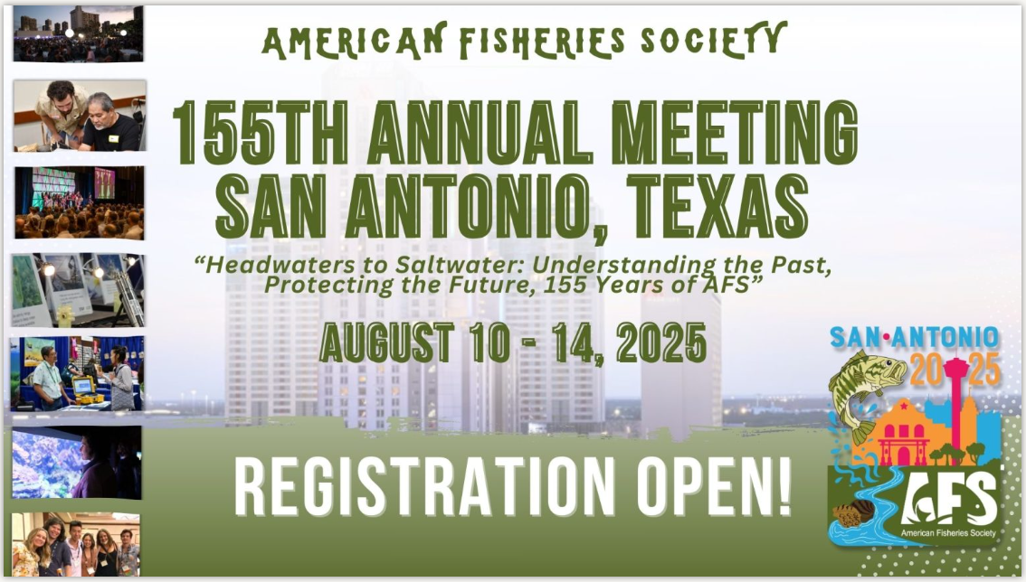
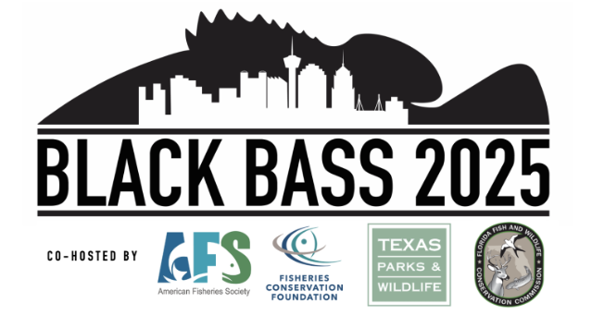

Total Estimated Travel Expenses
AFS 2025 Travel Expenses | Estimated Cost
Registration | $1,080
Continuing Education Full Day | $250
Flights Round Trip (August 9th-14th) | $400
1st Bag Outbound | $35
1st Bag Return | $35
Hotel (covered by HPUL) | $0
Uber/Rental Car (Ride with HPUL?) | -
GSA Meals Per Diem
4 full days at $74.00 | $296.00
First and last day at $55.50 | $111.00
TOTAL | $1,800

