Map Date 12/8/2023 Clearlake Oaks 1996 Quadrangle:Township 14N, Range 8W, Section 14

FINDINGS
No new prehistoric sites, historic sites, features or ethnographic sites were recorded during the survey. No previously recorded resources were noted within the Project Area.
The approximate 45-acre Project Area is comprised of a single parcel (APN 006-004-22) of lightly developed, rural land within an oak woodland environment and is situated in a rugged foothill topography within a mountain range setting. A modern, one room, corrugated sheet metal clad house, two storage sheds, multiple plastic 3,000-gallon water storage tanks, two Conex containers and multiple two track access roads are present on the property. Most of the future cultivation areas and current access roads have been cleared and graded by heavy machinery with 3-foot-deep trenches excavated within some of the access roads leading to these areas for PVC water pipelines. The parcel is generally bounded by undeveloped property on all sides, with a segment of a vineyard present along a portion of the southern boundary and a portion of High Valley Road along the northwestern edge of the property boundary. Access to the Project Area is from High Valley Road via Highway 20 in Clearlake Oaks, Lake County. Vegetation consisted of oak, buckbrush, manzanita and annual grass and forbs. Ground visibility within the Project Area was excellent (75-100%) within the two track roads, trenches, and the graded areas and poor (1-25%) within areas of dense vegetation (Photographs 1-10). Slope within the Project Area was moderate at 24-29%. Elevation varied from 1870-2511 feet amsl. Soils on the property were a Munsell yellowish brown (10YR 5/4) gravelly sandy clay loam, consistent with the Maymen soil series.
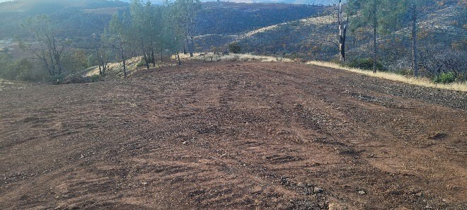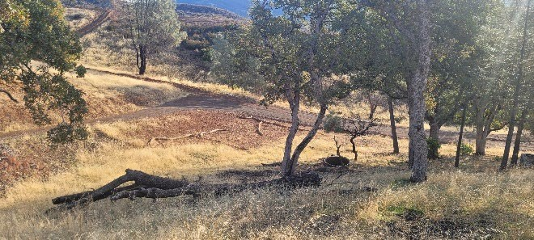

Photograph 1. Overview of planned grow area in
Project Area. View south.

Photograph 2.

Overview of planned grow area in
Project Area. View east.
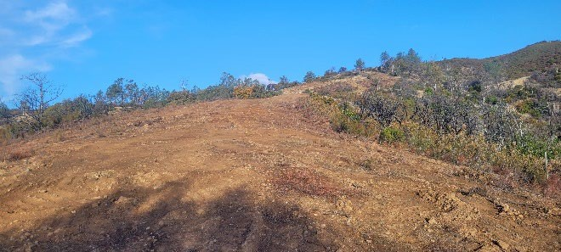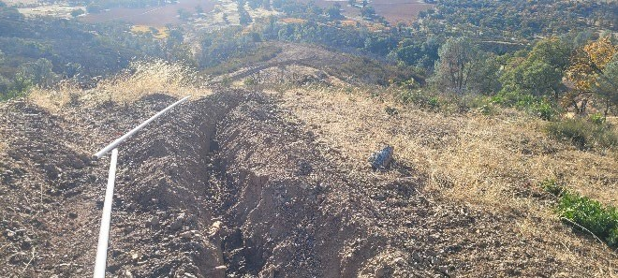

Photograph 3. Overview of planned grow area in Photograph 4. Overview of waterline trench. View
Project Area. View northwest. southeast.

